Case 5-A390-Asia-China-Liangzhu-Jade-Comb Back-Taotie-Early – Mid Liangzhu-3400-2800 BCE

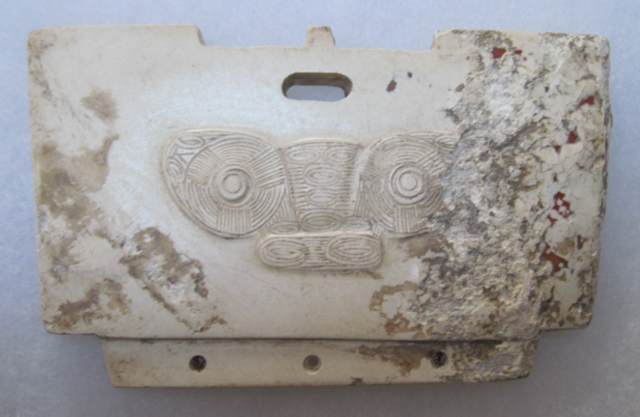

Figs. 1-2. China-Liangzhu-Jade-Comb Back-Early – Mid Liangzhu- 3400-2800 BCE

**Case no.: 5**

**Accession Number: A390**

**Formal Label:** China-Liangzhu-Jade-Comb Back-Early – Mid Liangzhu- 3400-2800 BCE

**Display Description:**

The Liangzhu Culture comb-back is generally a flat thin jade body with an even thinner tenon, which has two to five perforations that join the combs and comb-backs together. The brown staining on this one is due to the penetration of the hematic fluids of the deceased. This jadecomb-back recto has a bas-relief that is suggestive of the so-called “taotie” mask. The taotie is a bi-laterally symmetrical animal mask. It has been associated with an anthropomorphic Master of Animals wearing a feather headdress that suggests meditation on this image induce a shamanic trance. This iconography undoubtedly harkens back to a pre-Neolithic period when shamanic imagery was the symbolism of hunter-gatherers and was the imagery that was inscribed on petroglyph panels. Indeed, Hayashi Minao argues that the name of the cong/tsung derived from zhu/chu meaning "master" which we expand to "master of animal powers" (Hayashi 1990:6).

These comb-backs have been found carefully laid on the bodies of the deceased.

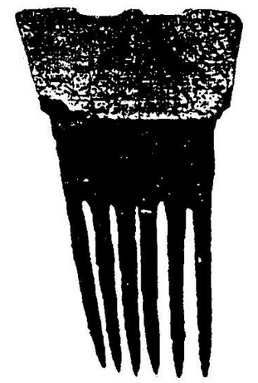

Fig. 3. Hair comb-back attached by a tenon to a comb base, from the Liangzhu Cultural Relics at the ruins of in Haining, Zhejiang Province, 1999. Found in a Liangzhu dignitary tomb at a depth of 110 cm, which unearthed jade, jade bracelet, jade Huang, jade back, jade bead string and a large number of early and middle period Liangzhu jade. After http://s10.sinaimg.cn/bmiddle/51784822hc6aa420a0859&690

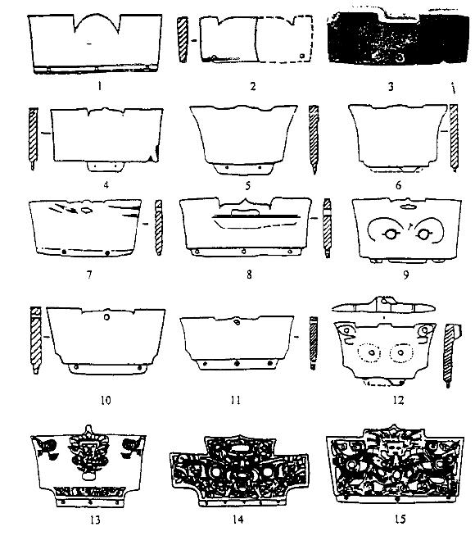

Fig. 4. Comb-back ornaments unearthed in the Liangzhu Site in the vicinity of Jiangzhe and Zheju, indicating the jade comb-back is one of the most distinctive jade ornaments of the Liangzhu culture, and its use was also a common phenomenon. After <http://s11.sinaimg.cn/large/51784822hc6aa423dc29a&690>

**LC Classification:** NK5750.2.A1

**Date or Time Horizon:** Liangzhu culture, lower Yangzi River Valley, early Liangzhu Period, ca. 3200 BCE **Geographical Area:** Liangzhu culture, lower Yangzi River Valley

**Map:**

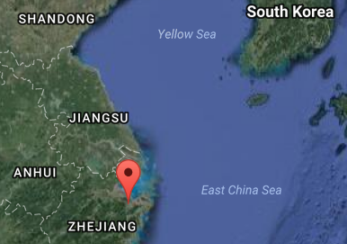

Fig. 5. Locastion of Liangzhu site proper.Source: Google Earth

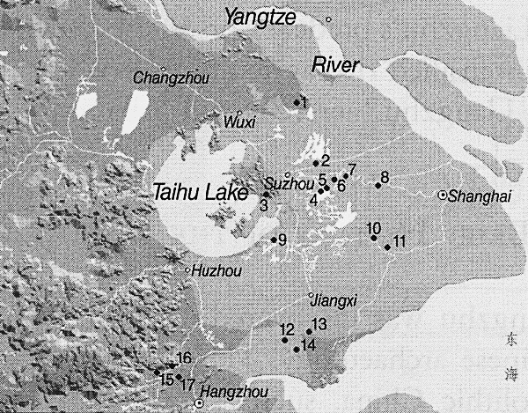

Fig. 6. Detail of Liangzhu site complex surrounding Taihu. After Zhou Ying 2007.

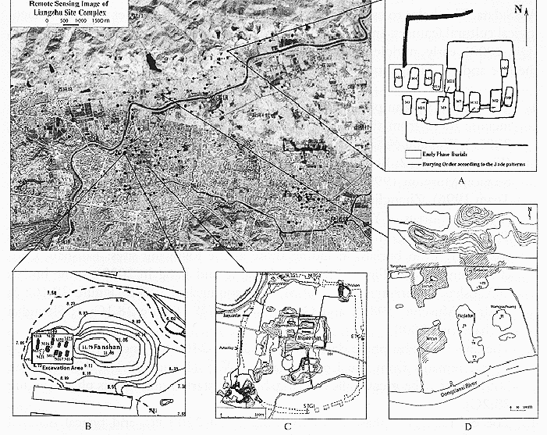

**Fig. 7.** Detail of Liangzhu site proper. After Zhou Ying 2007.

**GPS coordinates:**

Northeast corner: N 30°24'48", E 120°00'17"

Northwest corner: N 30°24'41", E 119°58'58"

Southeast corner: N 30°23'20", E 120 00'19"

Southwest corner: N 30°22'55", E 119°58'28"

**Cultural Affiliation:** Liangzhu culture, lower Yangzi River Valley, 3300-2250 BCE

**Medium:** Jade

**Cultural Affiliation:** Liangzhu

**Medium:** jade

**Dimensions:**

**Weight:**

**Condition: original**

**Provenance:**

**Discussion:**

Liangzhu (3400–2250 BCE) in Yuhang County, Zhejiang, became a highly stratified society in the latter Liangzhu Period ca 2800-2250 BCE when élites began to control a sphere of influence that extended north to Shanxi and south to Guangdong. Jade and other expensive wares (such as silk, lacquerware, and ivory) characterized the social symbolism of Liangzhu élites which they used in ritual performances and dances as well as in grave goods. In this period the previous rôle of the shaman was curtailed in its psychological component and elevated in its rational component as astronomer.

DNA from Liangzhu culture sites around Taihu Lake the Yangtze River exhibit high frequencies of Haplogroup O1 which was absent in other archaeological sites that were sampled inland of the Liangzhu complex. Haplogroup O1 is common to modern Austronesians and Taiwanese Aborigines/Taiwanese Austronesians (TAN) (O1) probably came from those Liangzhu Austronesians (LAN) who had been displaced from the mouth of the Yangtze River delta by an economic crash of the LAN ca 4500 BCE induced by a meteor that struck at the present location of Taihu Lake, a meteoric crater. Recent studies show that special micro-fractures in quartzite were formed during the unloading process after the compression at the peak of an impact event (Wang, Wan, Xu 2002). LAN culture sites that existed around Taihu Lake and the mouth of the Yangtze River succumbed by ca 4200 BP LAN to a series extreme floods from diversions of the Yangtze River that interrupted the cultural layers with intrusions of mud and sand. It took 800 years, from 4200 BCE until 3400 BCE, for the Liangzhu culture on the mainland to recover. At the end of this time-horizon, Taiwanese migrants began to sail east to the Buka Strait in the Solomon Islands which became a staging area for the populating of Polynesia ca 2500 BCE.

**References:**

Biot, Jean Baptiste. 1851. *Le Tcheou-li: ou, Rites des Tcheou*. Paris: Imprimerie nationale, 1851. 3v.

Chang, K.C., Xu, P. and Lu, L. 2005. *The formation of Chinese civilization: an archaeological perspective*. New Haven: Yale University Press.

Childs-Johnson, Elizabeth. 1988. *Ritual and Power: Jades of Ancient China*. New York: China House Gallery, China Institute in America.

Childs-Johnson, Elizabeth. 2009. “The Art of working Jade and the rise of civilization in China.” In Elizabeth Childs-Johnson, *Early Chinese jades in American Museums.* Beijing: The Science Press, China Science and Technology Publishing and Media Co., Ltd., 2009, pp. 291-393.

Gu Fang. 2005. *Complete collection of unearthed jades in China*. 15 v. Beijing: China Science and Technology Publishing and Media Co., Ltd.

Hayashi, Minao. 林巳奈夫. 1991. *Chūgoku kogyoku no kenkyū*. 中國古玉の研究. Tōkyō: Yoshikawa Kōbunkan; 東京 : 吉川弘文館, 1991.



Hayashi, Mineo. 1990. “On the Chinese Neolithic jade Tsung/Cong,” *Artibus Asiae*, 50(1/2):5-22.

Hayashi, Mineo. 1973. *Toyo Gakuho* [Journal of the Research Dept. of the Toyo Bunko] 45:1-57.

Laufer, Berthold. 1912. *Jade a study in Chinese archaeology and religion*. Field Museum of Natural History, Publication 154, Anthroplogical series, vol. X. Chicago.

Li, Hui; Huang, Ying; Mustavich, Laura F.; Zhang, Fan; Tan, Jing-Ze; Wang, ling-E; Qian, Ji; Gao, Meng-He; Jin, Li. 2007. "Y chromosomes of prehistoric people along the Yangtze River," Human Genetics **122**: 383–388.

Wang Erkang, Yuqiu Wan, Shijin Xu. 2002. “Discovery and implication of shock metamorphic unloading microfractures in Devonian bedrock of Taihu Lake,” *Science in China Series D: Earth Sciences*, 45 (5): 459–467.

Lu Wenbao. 1998. *Cong-shaped bead. In Liangzhu Culture Museum, ed., The dawn of Chinese civilization: Jades of the Liangzhu culture.* Hong Kong: Liangzhu Culture Museum and The Art Museum, The Chinese University of Hong Kong.

Wu, Li. 2014. "Holocene environmental change and its impacts on human settlement in the Shanghai Area, East China," Catena **114**: 78–89

Zhang, Chia; Hsiao-Chun, Hung. 2008. "The Neolithic of Southern China–Origin, Development, and Dispersal,"Asian Perspectives. **47**:2, 309–310.

|  |
| --- |
| Zhou Ying. 2007. 东方文明的曙光: 良渚遗址与良渚文化 = **Dong fang wen ming de shu guang : Liang zhu yi zhi yu liang zhu wen hua =** *The Dawn of the Oriental Civilization: Liangzhu site and Liangzhu culture*. Beijing: China Intercontinental Press. |